Experiment 4(b): Probability Distributions
Francis Reuben R
Department of Computer Science and Engineering, RV University
Data Science Laboratory, Semester 3, Section G | USN: 1RUA25CSE0168 | 24 September 2026

Objective
The experiment is to choose a probability distribution from the wording of a scenario, compute the required probability by hand, and check that value with scipy.stats. Discrete cases use a probability mass function and a bar chart. Continuous cases use a probability density function and a curve. Each plot has an x-label, a y-label, and a title. Probabilities are reported to 4 decimal places.

Description
A value that is counted is discrete. A value that is measured is continuous. Bernoulli is one yes-or-no trial. Binomial counts successes in a fixed number of identical trials (the BINS conditions). Poisson counts events in a fixed interval at a known average rate, and its mean equals its variance. Normal is a bell curve around a mean. Uniform gives every value in an interval the same density. For a uniform distribution on [a, b], scipy uses loc = a and scale = b - a.
Lab-4-b.ipynb has five taught scenarios: a penalty kick, faulty bulbs in a box, emergency cases in one night, packet weight, and random numbers on a fixed range. Lab-4-b-Assignment.ipynb is the 50-mark assignment, two questions on each distribution. The issued assignment file stops in the middle of several part (c) prompts and has no question text for Q4 or Q10. Those two questions were not invented. Every part that is present is answered in the notebook, with the outputs saved.

Flowchart
Figure 1 is the pipeline used in both notebooks. The distribution plots stay inside the notebooks. This record includes only the pipeline figure.
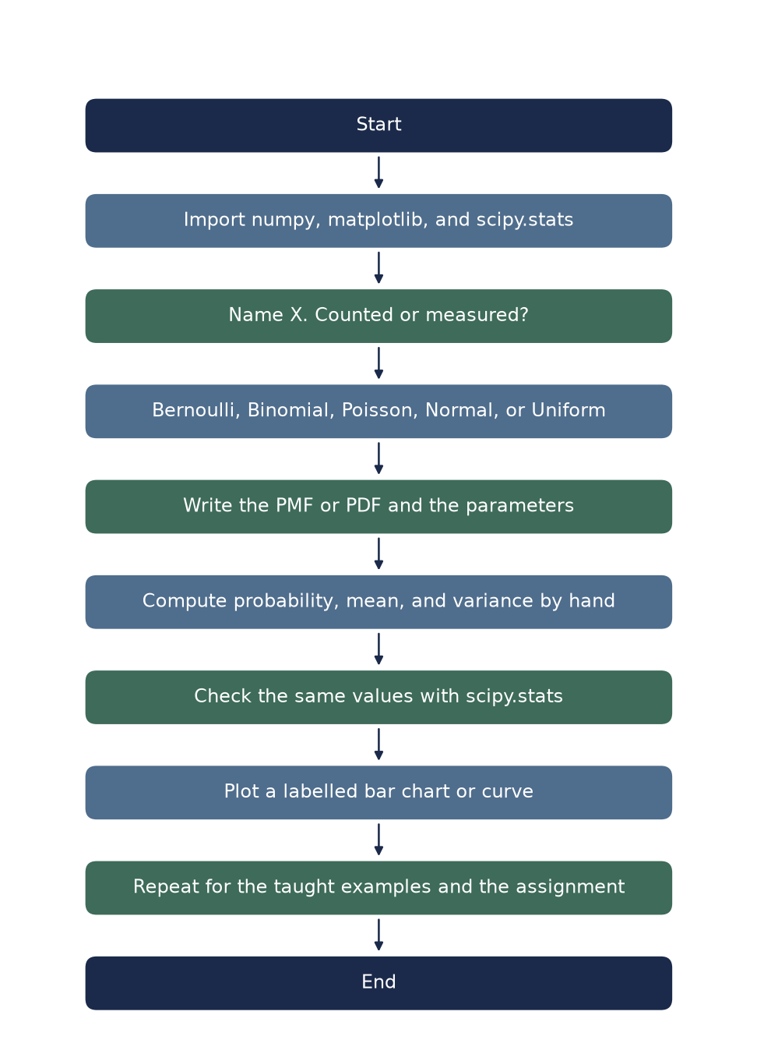
Figure 1. Pipeline for Lab 04b probability distributions.

Algorithm
- Start. Import numpy, matplotlib.pyplot, and scipy.stats. Set the discrete and continuous plot colours.
- Read the scenario. Name the random variable X and decide whether it is counted or measured.
- If it is counted, choose Bernoulli (one trial), Binomial (n fixed trials), or Poisson (events in an interval).
- If it is measured, choose Normal (values cluster around a mean) or Uniform (values in a range are equally likely).
- Write the PMF or PDF, substitute the parameters from the scenario, and compute the probability, mean, and variance by hand.
- Check the same quantities with scipy.stats (pmf or pdf, cdf or sf, mean, var, and ppf where a percentile is asked).
- Plot a bar chart for a discrete distribution or a curve for a continuous distribution. Label both axes and add a title.
- Repeat for the five taught scenarios and for each assignment question whose prompt is in the issued notebook.
- End.

Taught examples

Discrete
Penalty kick (Bernoulli). X = 1 if the kick is scored and X = 0 if it is missed, with p = 0.8. P(X = 1) = 0.8000 and P(X = 0) = 0.2000. The mean is 0.8000 and the variance is 0.1600. scipy.stats.bernoulli matches both.
Faulty bulbs (Binomial). A box has n = 15 bulbs and each bulb is faulty with p = 0.1. C(15, 2) = 105. P(X = 2) = 0.2669. The mean is 1.50 and the variance is 1.35. The bar for k = 2 is highlighted.
Hospital emergencies (Poisson). The average rate is lambda = 4 cases per night. P(X = 0) = 0.0183 and P(X = 4) = 0.1954. The mean and the variance are both 4.

Continuous
Packet weight (Normal). Weights have mean 500 g and standard deviation 5 g. The PDF is drawn on 400 points from 480 g to 520 g. The shaded interval from 495 g to 505 g has probability 0.6827, which is the mean plus or minus one standard deviation. The variance is 25.
Random numbers (Uniform). One thousand draws are taken on [10, 20] with random_state = 42. The theoretical mean is 15 and the theoretical variance is 8.3333. The sample mean of those draws is 14.9026. The histogram is overlaid with a flat PDF of height 0.1.

Scenario | Distribution | Checked result
Penalty kick | Bernoulli, p = 0.80 | P(score) = 0.8000, var = 0.1600
Faulty bulbs | Binomial, n = 15, p = 0.10 | P(X = 2) = 0.2669, mean = 1.50
Emergencies | Poisson, lambda = 4 | P(X = 0) = 0.0183, P(X = 4) = 0.1954
Packet weight | Normal, mean 500 g, sd 5 g | P(495 to 505 g) = 0.6827
Random numbers | Uniform on [10, 20] | mean = 15, var = 8.3333

Assignment results
Hand values below are the ones typed in Lab-4-b-Assignment.ipynb. scipy agrees, except P(X = 2) for the help-desk emails: the question gives e^(-3) as 0.0498, which produces 0.2241, while scipy uses the fuller value and prints 0.2240.

Q | Setup | Result
Q1 | Bernoulli, p = 0.92 | P(read) = 0.9200, var = 0.0736
Q2 | Bernoulli, p = 1740/2000 = 0.87 | var = 0.1131; largest var is 0.25 at p = 0.5
Q3 | Binomial, n = 12, p = 0.25 | C(12, 5) = 792, P(X = 5) = 0.1032
Q5 | Poisson, lambda = 3 | P(X = 0) = 0.0498; smallest k with CDF >= 0.95 is 6
Q6 | Poisson, lambda = 12 over 8 hours | P(X = 0) = 6.1442e-06, P(X > 18) = 0.0374
Q7 | Normal, mean 18 h, sd 1.5 h | Z(15 h) = -2; 95% interval is 15 to 21 h
Q8 | Normal, mean 200 ml | sigma = 5.1020 ml by hand; 1st percentile = 188.1307 ml
Q9 | Uniform on [0, 15] minutes | mean = 7.5 min, var = 18.75
Q2 also simulates 2,000 Bernoulli trials with random_state = 42. The simulated proportion of accepts is 0.8675, next to the theoretical p of 0.8700. A second figure plots p(1 - p) and marks the maximum at p = 0.5.
Q6 uses stats.poisson.sf(18, 12) for the probability that the night shift pages the engineer. Q8 finds sigma from stats.norm.ppf(0.975) rather than the rounded 1.96, which gives 5.1021 ml. P(fill under 190 ml) = 0.0250. Q4 and Q10 are absent from the issued notebook, so they are absent from this table.

GitHub
Course repository: https://github.com/francisreubenr-rvu/Data-Science-Labs
The files for this experiment are Lab-4-b.ipynb and Lab-4-b-Assignment.ipynb, in Semester-3/Labs-Semester-3/Lab 04b. The assignment notebook is the file submitted with this record. Its outputs are saved in the file.

